**PSUC Lab Assignment**

**Name**: Saksham Mamtani **Reg No**: 200903038

**Lab: 7**

Q1) Count the number of words in a sentence.

Code:

#include<stdio.h>

#include<string.h>

int main()

{

char str[50];

int i=0, count=1;

printf("Enter sentence\n");

gets(str);

while(str[i]!='\0')

{

if((str[i]==' '&&str[i+1]!=' '))

count++;

i++;

}

printf("no of words=%d",count);

printf("\nMy name is Saksham");

return 0;

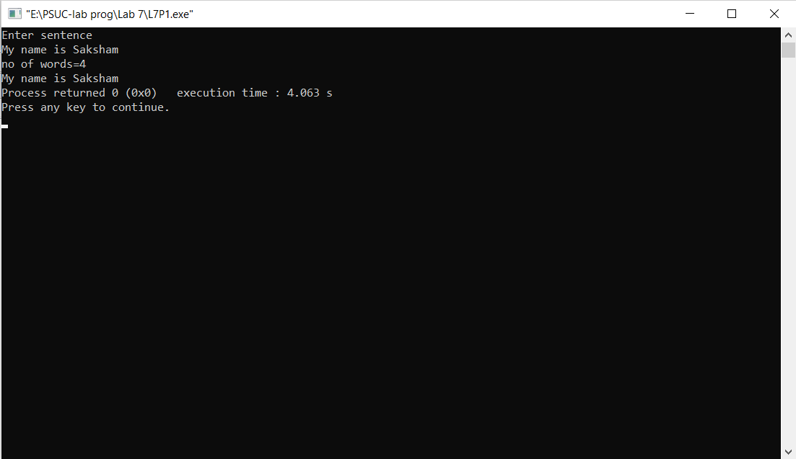}

Output:

Q2) Input a string and toggle the case of every character in the input string.

Code:

#include<stdio.h>

#include<string.h>

int main()

{

char str[100];

int i;

printf("Enter the string\n");

gets(str);

for(i=0;str[i]!='\0';i++)

{

if(str[i]>='A' && str[i]<='Z')

str[i]+=32;

else if(str[i]>='a' && str[i]<='z')

str[i] -=32;

}

printf("\n the modified string is: \n");

puts(str);

printf("My name is Saksham");

return 0;

}

Output:

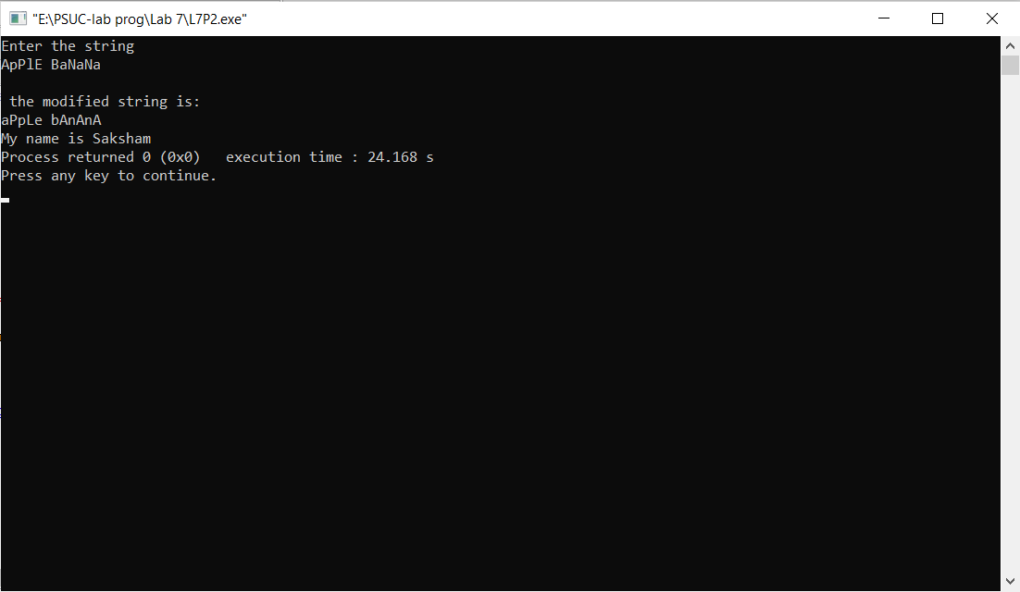

Q3) Check whether the given string is a palindrome or not.

Code :

#include<stdio.h>

#include<string.h>

void main()

{

char str[100];

int i,n=0,flag=0;

printf("Enter the String: \n");

gets(str);

for(i=0;str[i]!='\0';i++)

n++;

for(i=0;i<n/2;i++)

{

if(str[i]!=str[n-1-i])

{

flag=1;

break;

}

}

if(flag==0)

printf("It is a Palindrome!!!!\n");

else

printf("It is not a Palindrome!!!\n");

printf("My name is Saksham");

}

Output:

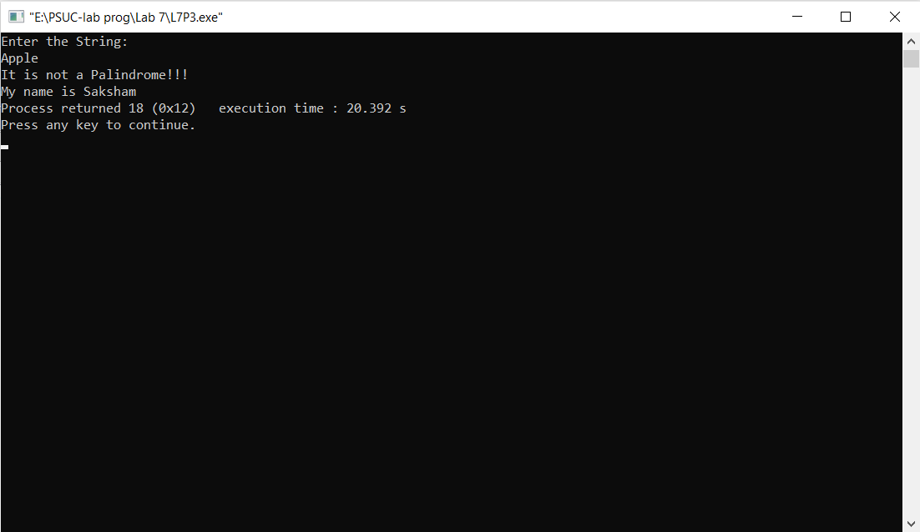

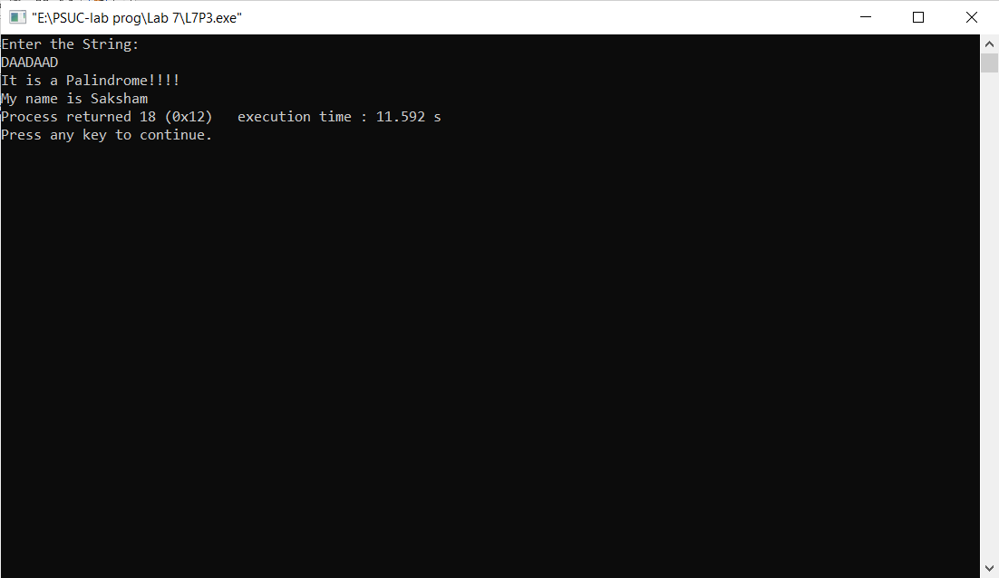

Q4) Arrange ‘n’ names in alphabetical order (hint: usestring handling function-strcpy)

Code:

#include <stdio.h>

#include <string.h>

void main()

{

char name[50][50],temp[25];

int n,i,j;

printf("Sorts the strings of an array using bubble sort :\n");

printf("Input number of strings :");

scanf("%d",&n);

printf("Input the %d Strings :\n",n);

for(i=0;i<=n;i++)

{

fgets(name[i], sizeof name, stdin);

}

for(i=1;i<=n;i++)

for(j=0;j<=n-i;j++)

if(strcmp(name[j],name[j+1])>0)

{

strcpy(temp,name[j]);

strcpy(name[j],name[j+1]);

strcpy(name[j+1],temp);

}

printf("The strings appears after sorting :\n");

for(i=0;i<=n;i++)

printf("%s\n",name[i]);

printf("My name is Saksham");

}

Output:

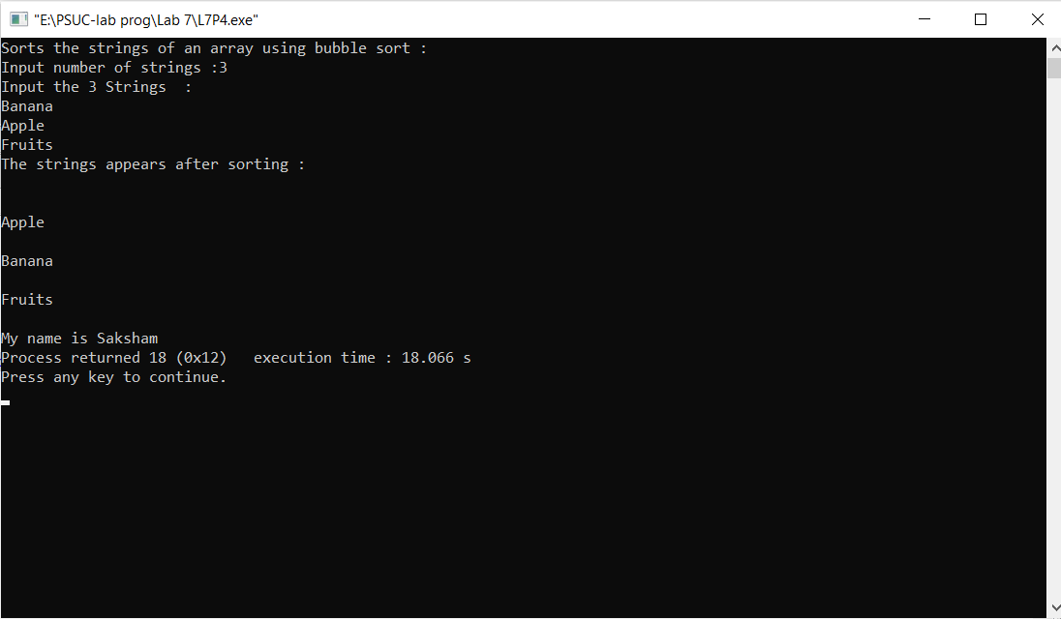

Q5) Delete a word from the given sentence.

Code:

#include<stdio.h>

#include<string.h>

void main()

{

char str[100],substr[50];

int i,j,k,pos,flag=0;

printf("Enter the main string/sentence\n");

gets(str);

printf("Enter the word to be deleted /substring\n");

fflush(stdin);

gets(substr);

j=0;

for(i=0;str[i]!='\0';i++)

{

if(str[i]==substr[j])

{

pos=i;

j=j+1;

for(k=pos+1; j<strlen(substr);k++,j++)// matching susbsequent characters of the substring

{

if (str[k] == substr[j])

continue;

else

{

j=0;

break;

}

}

}

if(j==strlen(substr))

flag=1;

}

if(flag==0)

printf("Word to be deleted is not found\n");

else

{

if(pos+strlen(substr)>=strlen(str))

str[pos]='\0';

else

{

for(i=pos;i<strlen(str);i++)

str[i]=str[strlen(substr)+i];

}

}

printf("The modified string is :\n");

puts(str);

printf("My name is Saksham");

}

Output:

